Interpretable Federated Learning for Blockchain Fraud Detection

EXECUTIVE RESEARCH BRIEFING & METHODOLOGICAL EVALUATION

Paper Title: | Interpretable Federated Learning for Fraud Detection in Non-IID Blockchain Transactions | Dataset: | Ethereum Fraud Detection (Kaggle)
Authors: | Mahmudul Hasan et al. | Nodes & Partition: | 20 Clients | IID & Dirichlet Non-IID
Core Problem: | Data Privacy vs. Non-IID Drift & Black-Box AI | Optimal Model: | 2-Layer NN + SGD (Non-IID Regime)

Executive Summary & Problem Statement

Decentralized blockchain networks offer transparent, immutable financial ledgers, but their pseudonymity exposes them to severe fraudulent activities, including phishing, double-spending, and Sybil attacks. Traditional machine learning (ML) solutions require pooling sensitive financial logs onto a central server, creating single points of failure and directly violating strict user privacy regulations (e.g., GDPR). While Federated Learning (FL) allows decentralized clients (crypto exchanges/wallets) to train models locally without sharing raw data, real-world FL implementations face two critical bottlenecks:
The Dual Challenges in Blockchain FL:
- Data Heterogeneity (Non-IID Drift): Client nodes hold radically unequal transaction distributions (e.g., retail wallets vs. institutional exchanges), causing severe model divergence and gradient instability.
- Black-Box Opacity: Financial regulators require human-understandable justifications for fraud alerts, which standard deep learning models fail to provide.

System Methodology & Pipeline Architecture

The authors introduce a unified 5-stage FL-XAI pipeline designed to achieve privacy, scalability, and transparency without adding network or computational overhead during model training:

Stage 1: Preprocessing & Imputation | Cleans raw logs, imputes missing values (continuous → mean, categorical → mode), and strips zero-variance columns.
Stage 2: Client Partitioning | Distributes data across 20 client nodes under IID (balanced) and Non-IID Dirichlet (α = 1.0, 0.1, 0.01) settings.
Stage 3: Local Training | Trains local models (2-Layer Neural Network vs. Tabular Transformer) using SGD, Adam, or AdaGrad optimizers.
Stage 4: FedAvg Aggregation | Central server aggregates local model weights via weighted averaging across communication rounds (200-500 CRs).
Stage 5: Post-Hoc XAI | Executes SHAP (via Shapash) and LIME centrally post-aggregation, adding zero communication overhead  to clients.

Dataset & Data Distribution Strategies

The study utilizes the Kaggle Ethereum Fraud Detection Dataset, refined into 20 core tabular features covering ERC20 token dynamics, Ether balances, smart contract interactions, and temporal intervals. To rigorously test client drift, the data is partitioned across 20 simulated nodes using a Dirichlet distribution:
Dirichlet Class-Label Allocation Formula:
p(x , ..., x ; α , ..., α ) = (1 / B(α)) ∏ x αi - 1
Where concentration parameter α dictates data heterogeneity: α = 1.0 represents low heterogeneity, α = 0.1 represents moderate
imbalance, and α = 0.01 represents extreme heterogeneity where clients hold nearly disjoint label subsets.
1 k 1 k i

Experimental Results & Performance Benchmarks

The empirical findings reveal a crucial trade-off between theoretical model capacity and federated stability under non-IID data drift:
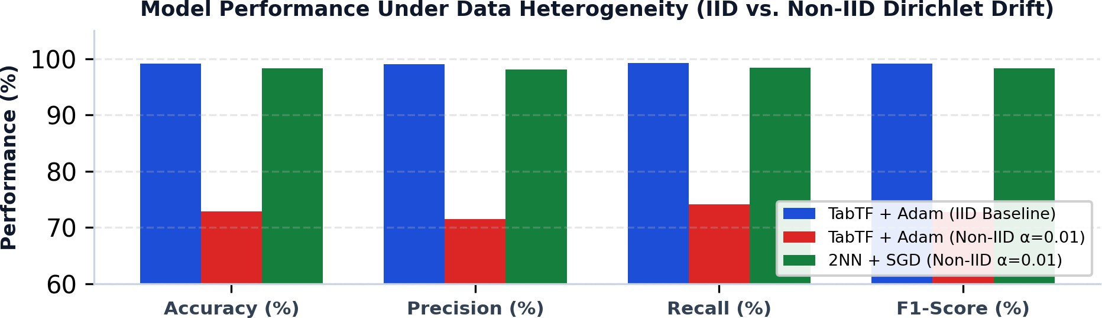
Figure 1: Classification Performance Under Uniform (IID) vs. Extreme Dirichlet Skew (α = 0.01)

Model & Optimizer | Data Setting | Accuracy (%) | F1-Score (%) | Std Dev (%) | Training Time (s)
TabTF + Adam | IID (Balanced) | 99.12% | 99.12% | ± 0.21% | 1,340 s
TabTF + Adam | Non-IID (α=0.01) | 72.88% | 72.78% | ± 10.15% | 2,410 s
2NN + SGD (Optimal) | Non-IID (α=0.01) | 98.25% | 98.25% | ± 0.58% | 192 s (6x Faster)
2NN + AdaGrad | Non-IID (α=0.01) | 96.24% | 96.18% | ± 0.82% | 210 s
Key Technical Takeaway: Why SGD Outperforms Adam in Non-IID Regimes:
Adaptive optimizers (Adam) accumulate second-moment gradient statistics locally. Under non-IID data skew, local gradients pull model parameters in conflicting directions, causing catastrophic weight oscillation and client drift. In contrast, Stochastic Gradient Descent (SGD) uses fixed-step updates that act as a natural regularizer, providing extreme parameter stability and rapid convergence.

Model Interpretability & Primary Fraud Predictors

By integrating Shapash (SHAP) and LIME post-aggregation, the framework opens the 'black-box' to reveal the core transactional drivers of blockchain fraud:

#1 Indicator: ERC20 Uniq Rec Token Name | High diversity in custom received token names is the single strongest signal of malicious smart contract interaction.
#2 Indicator: Total Ether Balance | Low or erratic wallet balances strongly correlate with disposable, automated scam accounts.
#3 Indicator: Avg Min Between Received Tnx | Extremely short temporal gaps between incoming transactions reflect automated high-frequency bot fraud.
#4 Indicator: ERC20 Max & Avg Value Sent/Rec | Sudden monetary value spikes in ERC20 transfers deviate from legitimate account baseline history.

Recommendations for Practical Deployment & Summary

Final Summary for Academic Evaluation:
- Architectural Choice: For real-world decentralized edge deployments with non-IID data distributions, lightweight models (2NN) paired with non-adaptive optimizers (SGD) outperform complex transformers in accuracy (98.25%), stability (±0.58%), and training speed (192 seconds).
- Privacy & Compliance: The FL setup guarantees raw data privacy, while central post-hoc XAI satisfies financial regulatory mandates with zero bandwidth overhead.
- Future Scope: Extend the framework to dynamic non-IID aggregation algorithms and automated smart contract bytecode auditing.

